Student worksheet

2.7 The rock cycle causes rocks to be reformed

Pages 30–31 and 165

The rock cycle

1 What is weathering?

2 What is erosion?

3 How are physical weathering, chemical weathering and biological weathering different from one another?

4 What is onion-skin weathering?

5 Which environment does onion-skin weathering occur in?

6 What is frost shattering?

7 Which environment does frost shattering occur in?

8 What chemicals are usually responsible for chemical weathering?

9 What is responsible for biological weathering? Explain how this process occurs.

10 On Earth, where are temperatures greatest?

11 On Earth, where is pressure at its greatest?

12 Label the following diagram of the rock cycle.

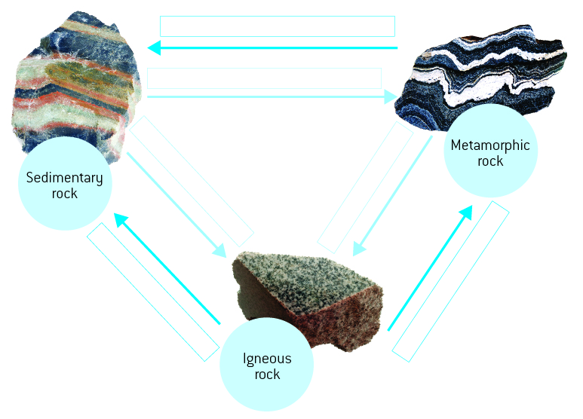

Extend your understanding

12 In a cartoon strip, explain the journey of a rock from the Earth’s surface, into the Earth and out through a volcano. You must describe all of the changes that happen to the rock and why, as well as all transformations that the rock undergoes.